# **Migrations and Models at Laravel**

Learn how to setup database and models

## **Overview**

In this document you’ll learn database setup with mysql and doing migrations of Laravel. It also scopes how to create table and create models for your database.

## **Laravel Artisan Models**

Using the command of “**php artisan make:model Todo**”. It will create a model class to connect and interact to our mysql database. You can find the generated file in “**app/Models/Todo.php**”

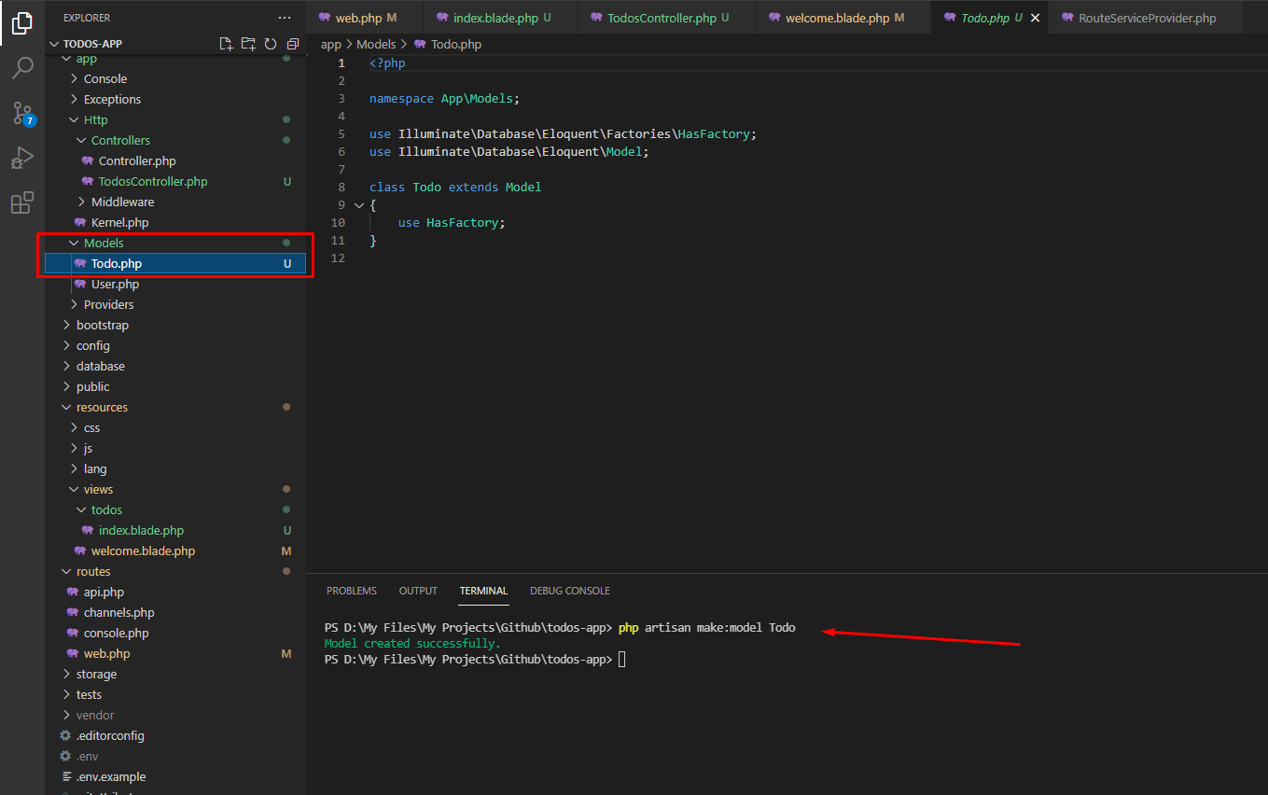

### Creating Migration Table

In order to create tables in Laravel and to sync it to your database you need to run this command in your terminal “ **php artisan make:migration create_todo_table** ”. In my case I created migration table with database table name of todo “ **create_*nameoftable*_table** ”

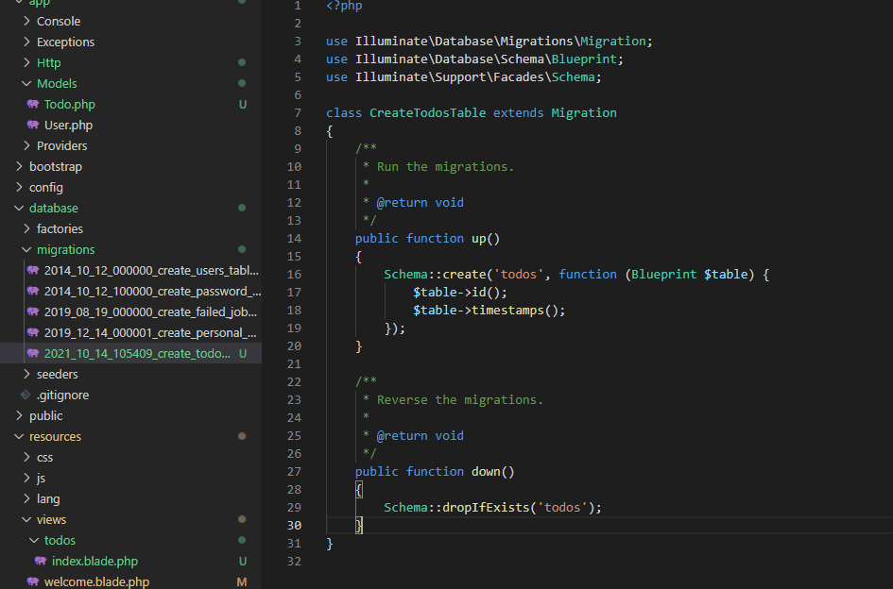

### Connecting Mysql in Laravel artisan

To connect your database from mysql to laravel you need to run “ **php artisan migrate** ”. It should work and when you go to database phpMyAdmin there’s generated table there.

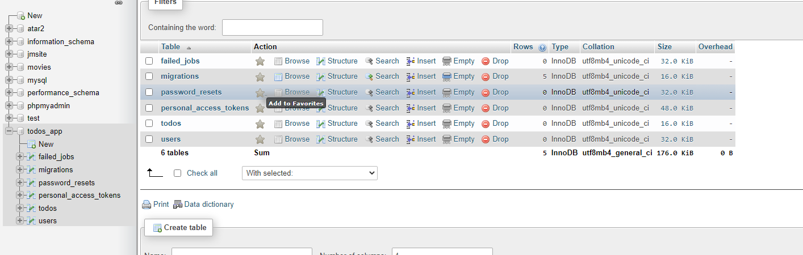

### Rollback the migration tables

To remove or rollback the migrated tables you can run this command “ **php artisan migrate:rollback**  ”. Check your phpMyAdmin and tables will be gone.

### Adding/Creating columns in database table

You can add or create new columns for database table by editing the migration table that you created in path “ **database/migrations/tablename.php** ”.

public function up()

    {

        Schema::create('todos', function (Blueprint $table) {

            $table->id();

            $table->string('name');

            $table->text('description');

            $table->boolean('completed');

            $table->timestamps();

        });

    }

**Notes:**

In every changes you made you need to run a command to refresh the connection of your tables to your database. Just type “**php artisan migrate:refresh**”. It will refresh your database from rollback to recreating the tables and its columns.